SOFTWARE REQUIREMENT SPECIFICATION (SRS)

HOMESTAY MANAGEMENT SYSTEM

2015

KHAIRUL ANWAR BIN HALMIN CB14006

RAZANALIA ERMA BINTI RAZALI CB14055

TENGKU NAZIHAH BINTI UNGKU SETEA CB14054

CLEMENT CB14048

ZUHURA HASSAN CB14116

THE INSIGHTS TECHAWARE SDN. BHD.

To be submitted to the Software Planning & Requirement Workshop

Bachelor of Computer Science (Software Engineering)

# DOCUMENT APPROVAL

|  |  |  |
| --- | --- | --- |
|  | **Name** | **Date** |
| **Authenticated by:**  _______________________  Project Manager | KHAIRUL ANWAR BIN HALMIN |  |
| **Approved by:**  _______________________    Client  (Manager) | ENCIK SYED MOHD FAISAL BIN SYED ALIAS |  |

Software : Microsoft Word,Rational Software Architect, Microsoft Excel

Archiving Place : https://www.facebook.com/groups/883212338430813/

Copies Available : Hardcopy-BCS2333-S02-G04-SRS V.1.0

# TABLE OF CONTENTS

DOCUMENT APPROVAL ii

TABLE OF CONTENTS iii

LIST OF FIGURES iv

LIST OF TABLES v

LIST OF APPENDIXES vi

1. INTRODUCTION 1

1.1 PURPOSE 1

1.2 SYSTEM IDENTIFICATION 1

1.3 SYSTEM OVERVIEW 2

1.4 REFERENCES 2

1.5 DOCUMENT OVERVIEW 3

2. PRODUCT DESCRIPTION 4

2.1 BUSINESS PROCEDURE 4

2.2 SYSTEM REQUIREMENTS 5

2.3 SYSTEM BOUNDARY 6

2.4 SYSTEM INTERFACE 8

2.4 SYSTEM FUNCTION 9

2.5 CONSTRAINTS 9

2.6 ASSUMPTIONS AND DEPENDENCIES 10

3. SPECIFIC REQUIREMENTS 11

3.1 SOFTWARE PRODUCT FEATURES 11

3.1.1 REGISTRATION USE CASE 11

3.1.2 MANAGE HOMESTAY USE CASE 13

3.1.3 RESERVATION USE CASE 15

3.1.4 FILTER USE CASE 17

3.1.5 PROMOTION USE CASE 19

3.1. 6 MANAGE TOURISM HOMESTAY 22

3.2 USER INTERFACE REQUIREMENT 25

3.2.1GRAPHICAL USER INTERFACE 25

3.2.1SOFTWARE INTERFACE 27

3.2.1HARDWARE INTERFACE 27

3.3 REQUIREMENTS TRACEBILITY 28

4. ACRONYMS AND ABBREVIATION 30

# LIST OF FIGURES

2.1 BUSINESS PROCESS MODEL 4

2.2 SYSTEM BOUNDARY 7

2.3 USE CASE DIAGRAM 8

3.1 USE CASE REGISTRATION 11

3.2 DECOMPOSE USE CASE REGISTRATION 11

3.3 USE CASE MANAGE HOMESTAY 13

3.4 DECOMPOSE USE CASE MANAGE HOMESTAY 13

3.5 USE CASE RESERVATION 15

3.6 DECOMPOSE USE CASE RESERVATION 15

3.7 USE CASE FILTER 17

3.8 DECOMPOSE USE CASE FILTER 17

3.9 USE CASE PROMOTION 19

3.10 DECOMPOSE USE CASE PROMOTION 20

3.11 USE CASE TOURISM SERVICES 22

3.12 DECOMPOSE USE CASE TOURISM SERVICES 23

3.13 DIALOGUE DIAGRAM 25

3.14 TRACEABILITY 28

# LIST OF TABLES

1.1 EXPLANATION OF SRS 3

2.1 SYSTEM REQUIREMENTS 5

2.2 LIST OF SYSTEM CONTEXT 6

2.3 LIST OF ACTOR 8

2.4 USE CASE DESCRIPTION 9

3.1 REGISTRATION USE CASE DESCRIPTION 12

3.2 MANAGE HOMESTAY USE CASE DESCRIPTION 14

3.3 RESERVATION USE CASE DESCRIPTION 16

3.4 FILTER USE CASE DESCRIPTION 18

3.5 PROMOTION USE CASE DESCRIPTION 20

3.6 TOURISM SERVICES USE CASE DESCRIPTION 23

3.7 DESCRIPTION USER INTERFACE COMPONENTS 26

3.8 SOFTWARE INTERFACE 27

3.9 TRACEABILITY 29

4.1 ACRONYMS AND ABBREVIATION 30

LIST OF APPENDIXES

APPENDIX A – 1 REGISTRATION ACTIVITY DIAGRAM 31

APPENDIX A – 2 MANAGE HOMESTAY ACTIVITY DIAGRAM 32

APPENDIX A – 3 RESERVATION ACTIVITY DIAGRAM 33

APPENDIX A – 4 FILTER ACTIVITY DIAGRAM 33

APPENDIX A – 5 PROMOTION ACTIVITY DIAGRAM 34

APPENDIX A – 6 TOURISM SERVICES ACTIVITY DIAGRAM 34

APPENDIX B – 1 GENERAL LOGIN PAGE 35

APPENDIX B – 2 HOST LOGIN PAGE 35

APPENDIX B – 3 CUSTOMER LOGIN PAGE 36

APPENDIX B – 4 ADMIN LOGIN PAGE 36

APPENDIX B – 5 HOME PAGE 37

APPENDIX B – 6 CUSTOMER DETAILS PAGE 37

APPENDIX B – 7 ACCEPT PROMOTION PAGE 38

APPENDIX B – 8 UPDATE & DELETE PROMOTION PAGE 38

APPENDIX B – 9 HOST & HOMESTAY DETAILS PAGE 39

APPENDIX B – 10 MANAGE TOURISM SERVICES PAGE 39

APPENDIX B – 11 REGISTRATION PAGE 40

APPENDIX B – 12 HOST REGISTRATION PAGE 40

APPENDIX B – 13 CUSTOMER REGISTRATION PAGE 41

APPENDIX B – 14 HOMESTAY FILTER PAGE 41

APPENDIX B – 15 CHECK PROMOTION PAGE 42

APPENDIX B – 16 MANAGE PROMOTION PAGE 42

APPENDIX B – 17 TOURISM SERVICES PAGE 43

APPENDIX B – 18 RESERVATION PAGE 43

APPENDIX B – 19 EDIT RESERVATION PAGE 44

APPENDIX C – PHOTO 45

1. INTRODUCTION

Homestay is a cultural exchange between a local individual or family (called a host) and a customer. The customer lives for an agreed period of time as a guest in host home.

## PURPOSE

The software Requirement Specification (SRS) documentation specifies the requirement for a Computer Software Configuration Item (CSCI) and the methods to be used to make sure that each requirement is completely satisfied. The purpose of the Software Requirements Specification is to outline the requirement for Homestay Management to build the Homestay Management Systems. This system will be built using JAVA, PHP and SQL oracle using the content management system.It will be operating system independent and accessible with any standard compliant browser.

* 1. **SYSTEM IDENTIFICATION**

Unique control number is given to each document created during this development of this project. Below shows the schema of the document numbering pattern:

|  |
| --- |
| <COMPANY NAME> - <SYSTEM NAME> - <TYPE OF DOCUMENT><VERSION> |

e.g TITSB– HMS- SRS- v.1.0

From the example shown above, ‘TITSB’ is a unique label which refers to our company name. ‘HMS’ refers to system name which is system that was developed by our team. ‘SRS’ refers to the abbreviation of the current type of document which in this case marks Software Requirement Specification. ‘V.1.0’ remarks the versioning control of the document which will increment based on perspective minor and major changes.

|  |
| --- |
| <SYSTEM NAME> - <TYPE OF REQUIREMENT & TYPE OF USER> - <USER IDENTIFIER> |

e.g HMS-FC– 01

From the example shown above,’HMS’ is a unique label which refers the system name.’FC’ refers to type of requirement and user such as F for functional requirement and C for customer.’01’ refers to user identifier which is added to recognize the requirement throughout the system starting by added series of sequence number starting from ‘01’.

|  |
| --- |
| <SYSTEM NAME> - <USE CASE> - <USE CASE IDENTIFIER> |

e.g HMS-UCD-01

From the example shown above,’HMS’ is a unique label which refers the system name. ‘UCD’ refers to use case diagram and ’01’ refers to use case identifier which is added to recognize the use case throughout the system starting by added series of sequence number starting from ‘01’.

|  |
| --- |
| <SYSTEM NAME> - <GUI> - <GUI IDENTIFIER> |

e.g HMS-DD-01

From the example shown above,’HMS’ is a unique label which refers the system name. ‘DD’ refers to dialog diagram and ’01’ refers to dialog diagram identifier which is added to recognize the dialog diagram throughout the system starting by added series of sequence number starting from ‘01’.

## SYSTEM OVERVIEW

Homestay Management System is a free online software solution that will manage the entire homestay booking process for customer. The purpose of the project is to analyse the requirements of design, implement, and maintain the system according to the requirements specified by the client and also manage the data systematically. This system involved registration, reservation, tourist attraction, search filter and promotion.

After gathering requirements, we have found homestay is using a manual file based system for their processes. They are keeping a huge amount of files handle customer details, bills, inventory items and etc. Search for record in the system is really harsh. Although they are not well secured there is a probability of getting damaged due to a fire or any other kind of a disaster.

The system aimed to build a fully functional system in order to achieve an efficient homestay management. The overall mission of system development is to make the homestay admin and host complete the homestay task quickly and easily. The system will also secure the record from getting damaged.

This system always a user friendly system. It helps to ease user with facilities for reservation process. It saves time which was waste more and more in manual performance of homestay and that time can be used in effective way to enhance the revenue. The system can be divided into departments according to their various functions.

## 1.4 REFERENCES

* Overmyer, S. P. (1990). *The Impact of DoD-Std-2167A on Iterative Design Methodologies*. Retrieved from ACM SIGSOFT Software Engineering Notes: http://www.cmmi.co.uk/engineering/2167a-and-iterative-design.htm
* *Software Development Plan*. (n.d.). Retrieved from AcqNotes: http://acqnotes.com/acqnote/careerfields/software-development-plan
* *Software Functional Configuration Audit*. (n.d.). Retrieved from AcqNotes: http://acqnotes.com/acqnote/careerfields/software-functional-configuration-audit

## DOCUMENT OVERVIEW

This document is a Software Requirements Specifications. The purpose of the Software Requirements Specification is to outline the requirement for Homestay Management to build the Homestay Management Systems.

Table 1.1 Shows the explanation of this SRS into 4 chapters.

|  |  |
| --- | --- |
| Chapter | Explanation |
| 1. Introduction | This chapter will generally describe about the purpose of SRS and problem faced from the current system. |
| 1. Overall Descriptions | This chapter describe the general factors that affect the product and its requirements. |
| 1. Specific Requirements | This chapter describe all the details of the software requirements which will enable developer and designer to develop and design a system which satisfy those requirements. |
| 1. Definitions, Acronyms and Abbreviation | This chapter describe all terms, acronyms, and abbreviations that used to help the readers understand the SRS. |

**Table 1.1**: Explanation of SRS

# 2. PRODUCT DESCRIPTION

**2.1 Business procedure**

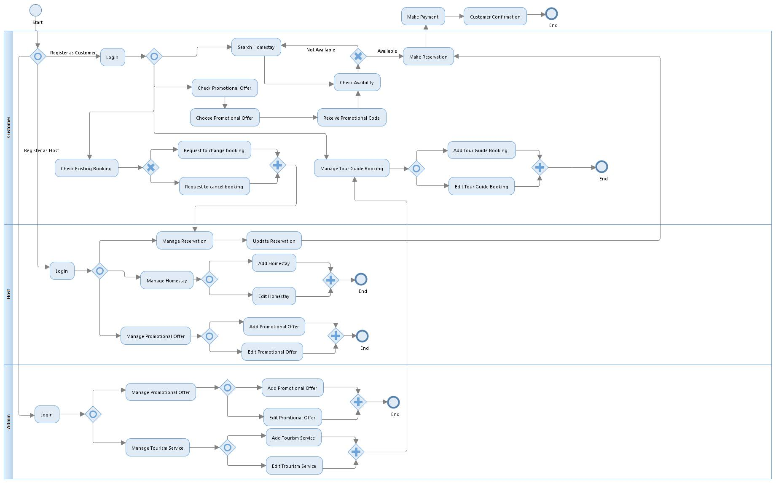**Figure 2.1**: Business process model for HMS

### 2.2 System Requirements

**Table 2.1**: System requirement for HMS

|  |  |
| --- | --- |
| **Requirement ID** | **Requirement** |
| HMS-FRC-01 | The customer shall register before do reservation |
| HMS-FRH-02 | The host shall register before they allowed promoting their homestay. |
| HMS-FMH-01 | The host should fill in their homestay details before add new homestay into the system. |
| HMS-FMH-02 | The host will be able to add and edit their homestay information for update latest information into the database. |
| HMS-FMR-01 | The customer will be able to do reservation on the homestay when it has availability status in date. |
| HMS-FMR-02 | The customer shall view purchase information before select homestay to booking. |
| HMS-FSF-01 | The system shall filter search result according to searching option for the customer usage. |
| HMS-FSF-02 | The host shall be able to manage filter search result of homestay. |
| HMS-FVP-01 | The system should be able to generate promotion code for registered customer who use promotion offer provided. |
| HMS-FVP-02 | The system shall allow the host to promote their homestay by manage and check promotion post. |
| HMS-FVP-03 | The system shall allow the host sends notification to customer either their homestay still available or not. |
| HMS-FVP-04 | The admin will be able to manage promotion offer and confirm any drafted post for instance promotion post. |
| HMS-FMT-01 | The customer shall fill in new tour guide booking details before they be able to manage tour guide information. |
| HMS-FMT-02 | Admin will be able to manage tour guide details by add and edit tour guide details. |

## 2.3 System Boundary

**Table 2.2**: List of system context

|  |  |
| --- | --- |
| **People (User)** | |
| Host | The registered host will be able to manage homestay details, manage promotional offers and tourism services. |
| Guest | The registered guest will be able to search and view homestays to make reservations, and view promotions and tourism services. |
| Admin | The administrator will be able to manage homestay and members database, and supervise on what is being posted. |
| **External Process** | |
| Payment | The payment transaction will be between the host and the guest by the host’s desired payment transaction. |
| Customer confirmation | This includes the check-in and check-out processes done after successful payment, for instance, handing over the key. |
|  |  |

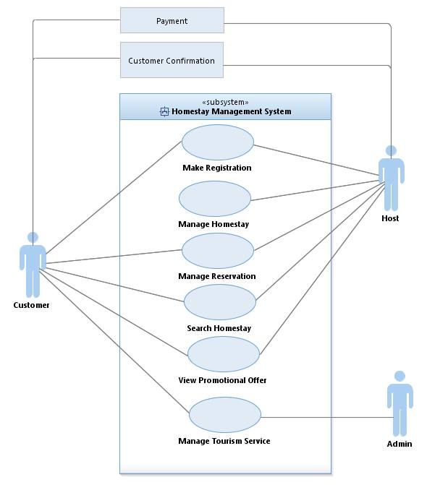 **Figure 2.2**: System boundary for HMS

## 2.4 System Interface

**Table 2.3**: List of actor

|  |  |
| --- | --- |
| **Actor** | **Description** |
| Customer | The customer will be able to to register and make reservations of the homestay they prefer. They can search for a homestay based on their filtered search options. They can view promotion posts and receive promotion code, as well as, any available tourism services. |
| Admin | The Admin will be able to manage the databases of homestays, registered hosts and guests. He will send notifications to the Host for any news or updates, and also confirm any drafted posts for instance promotion post. |
| Host | The host will be able to register and add their respective homestay to the system based on available search filters, notify the guest of any promotion posts or any updates on the homestay. Any edits done to homestay details, are first checked with the Admin and then finally posted. |

## 2.5 System Function

**­­­­­** 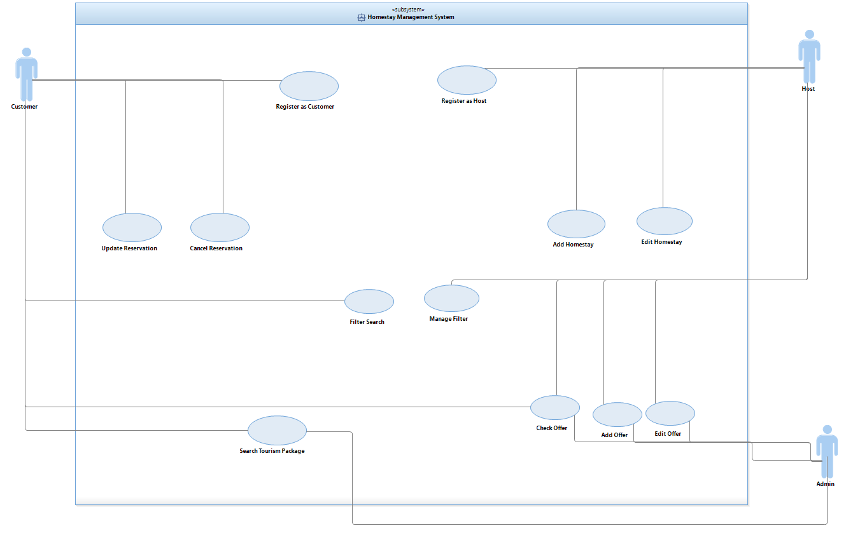

**Figure 2.3**: Use case diagram for HMS

|  |  |
| --- | --- |
| **Use Case** | **Descriptions** |
| Make Registration | * Customer, host and admin must register their account. * Customer, host and admin should fill their information in the form given before able to enter the system. |
| Manage Homestay | * Host able to manage their homestay detail. * System allow the host to add and edit their homestay detail for update latest information into the database. |
| Manage Reservation | * Customer able to manage their reservation after successfully registers as a member. * System allow customer to add, edit, and cancel reservation. * Customer must view purchase information before select homestay to booking. |
| Search Homestay Filter | * System allow customer to filter desired information about homestay by searching option * Host able to manage search result |
| View Promotional Offer | * System generates promotion code to customer who uses promotion offer provided. * Host of homestay sent notification to customer either the homestay is still available or not. * Admin able to add, edit and check promotion offer. |
| Manage Tourism Service | * Customer must fill the tour guide detail in the form provided before make tour guide booking. * Customer select tour guide available after fill the tour guide detail. * Admin need to add tour guide information into the system * Admin edit the current tourism service to get new update information about tour guide. |

**Table 2.4**: Use Case Description

## 2.6 System Constraints

1. User must register in order to use the system.
2. One user only have one ID.
3. Internet is needed to access the portal.
4. Users can login 3 times only. If the user failed to login,system will be terminate.

## 2.7 Assumptions and Dependencies

Some software used in implementing the system is with high cost and the client has agreed to afford the amount of money needed to purchase them. It’s assumed that client won’t change that decision on the next phases of the software development. Although we assume that client is using windows 7 or windows 8. Otherwise if client use an open source operating system, there is a need of changing the SRS accordingly.

# 3. SPECIFIC REQUIREMENTS

## 3.1 Software Product Features

### 3.1.1 Registration Use Case

Figure 3.1, 3.2 and table 3.1 show the use case, decomposed use case (sea level) and use case description of register host and customer from the registration module.

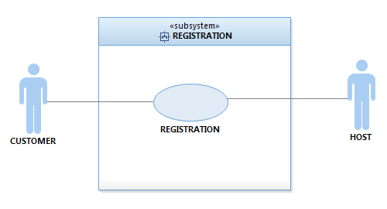

**Figure 3.1:** Use Case for Registration Module.

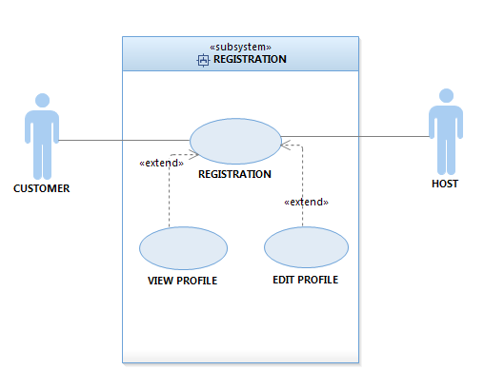

**Figure 3.2:** Decompose Use Case Registration Module

**Table 3.1** Register Use Case Description

|  |  |
| --- | --- |
| **Use Case ID** | HMS-UCD-01 |
| **Brief Description** | Host and customer can register to the system |
| **Actor** | Host and customer |
| **Pre-Conditions** | Host and customer need to enter the system’s homepage |
| **Basic Flow** | Customer   1. Customers choose registration at the home page. 2. Customers enters personal information in required fields. 3. Customers receives confirmation link through email.   Host   1. Hosts choose registration at the home page 2. Hosts enters personal information as well as homestay details in required fields. 3. Host receives confirmation link through email. |
| **Alternative Flow** | N/A |
| **Exception Flow** | 1. Network error.   1a. Registration rolled back. User restarts.   1. Required fields are empty or with invalid input.   2a. Registration rolled back. User restarts. |
| **Post-Conditions** | Host or customer successfully register to the system. |
| **Rules** | N/A |
| **Constraints** | Host and customer cannot register twice |
| **Activity Diagram** | Refer Appendix  A-1 : Activity diagram |

### 3.1.2 Manage Homestay Use Case

Figure 3.3, 3.4 and table 3.2 show the use case, decomposed use case (sea level) and use case description of homestay management from the manage homestay module.

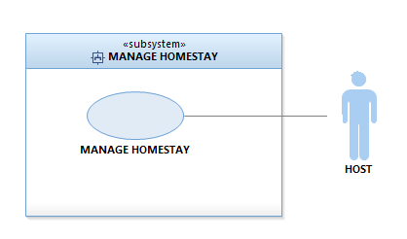

**Figure 3.3:** Use Case for Manage Homestay Module.

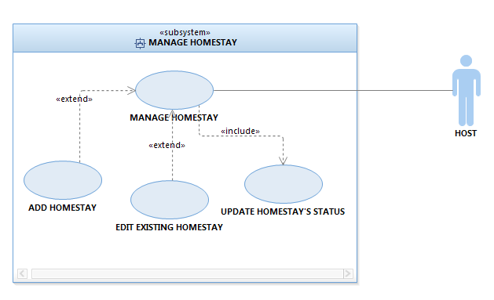

**Figure 3.4:** Decompose Use Case Manage Homestay Module

**Table 3.2** Manage Homestay Use Case Description

|  |  |
| --- | --- |
| **Use Case ID** | HMS-UCD-02 |
| **Brief Description** | Hosts manages their Homestay’s information. |
| **Actor** | Host |
| **Pre-Conditions** | Host needs to be logged in to the system |
| **Basic Flow** | 1. Hosts can add more homestays and update homestays’ status. 2. Hosts can edit homestays’ details and save the changes. |
| **Alternative Flow** | N/A |
| **Exception Flow** | 1. Incomplete or invalid input.   1a. Transaction rolled back. Host changes or completes details.   1. Maximum number of homestays per host reached.   2a. Host cancels the transaction. |
| **Post-Conditions** | Hosts successfully add and edit homestays’ details. |
| **Rules** | N/A |
| **Constraints** | Homestay’s status not automatically updated |
| **Activity Diagram** | Refer Appendix  A-2 : Activity diagram |

### 3.1.3 Manage Reservation Use Case

Figure 3.5, 3.6 and table 3.3 show the use case, decomposed use case (sea level) and use case description of booking homestay from the manage reservation module.

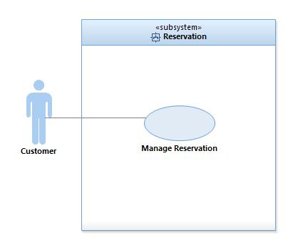

**Figure 3.5:** Use Case for Manage Reservation Module.

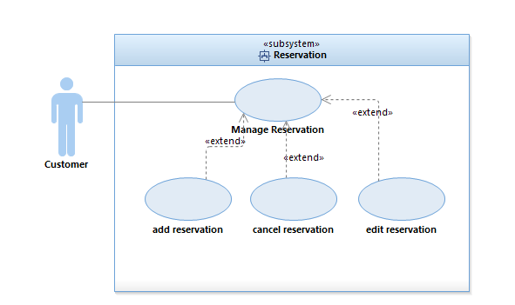

**Figure 3.6:** Decompose Use Case Manage Reservation Module

**Table 3.3** Manage Reservation Use Case Description

|  |  |
| --- | --- |
| **Use Case ID** | HMS-UCD-03 |
| **Brief Description** | Customer make homestay reservation. |
| **Actor** | Customer |
| **Pre-Conditions** | Customer need to be logged in to the system |
| **Basic Flow** | Customer   1. Customer enters Check-in and Check-out dates. 2. Customer fills the information needed in the reservation form provided. 3. Customer can view existing booking if they want to edit or cancel reservation. 4. Customer can edit current reservation after successfully finish the booking. 5. Customer able to cancel the reservation. |
| **Alternative Flow** | N/A |
| **Exception Flow** | 1. Homestay not available during the stay-in dates.   1a1. Customer returns to homepage and changes the check-in and check-out dates.  1a2. Customer quits the transaction. |
| **Post-Conditions** | The customer successfully submit reservation form. |
| **Rules** | N/A |
| **Constraints** | Customer cannot print the reservation form. |
| **Activity Diagram** | Refer Appendix  A-3 : Activity diagram |

### 3.1.4 Search Homestay Use Case

Figure 3.7, 3.8 and table 3.4 show the use case, decomposed use case (sea level) and use case description of searching homestay from the search homestay module.

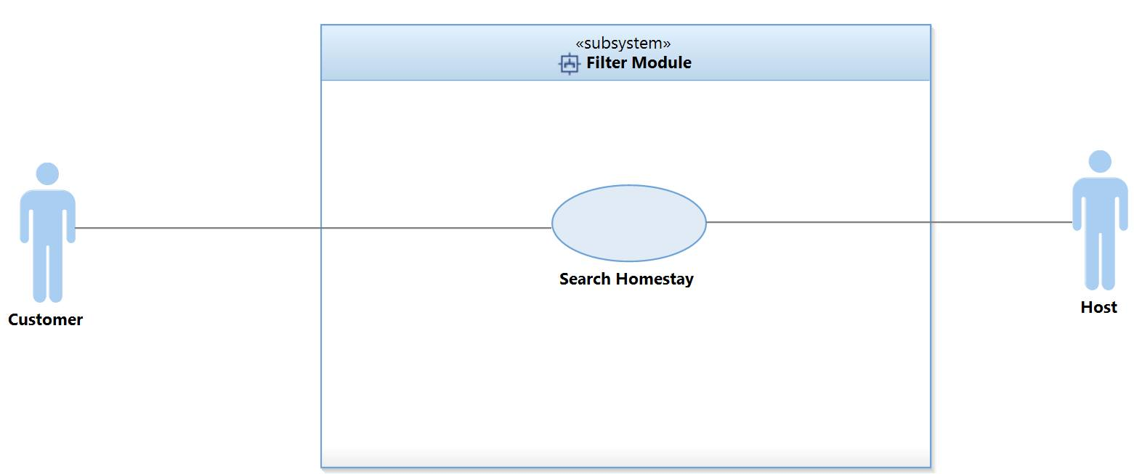

**Figure 3.7:** Use Case for Search Homestay Module.

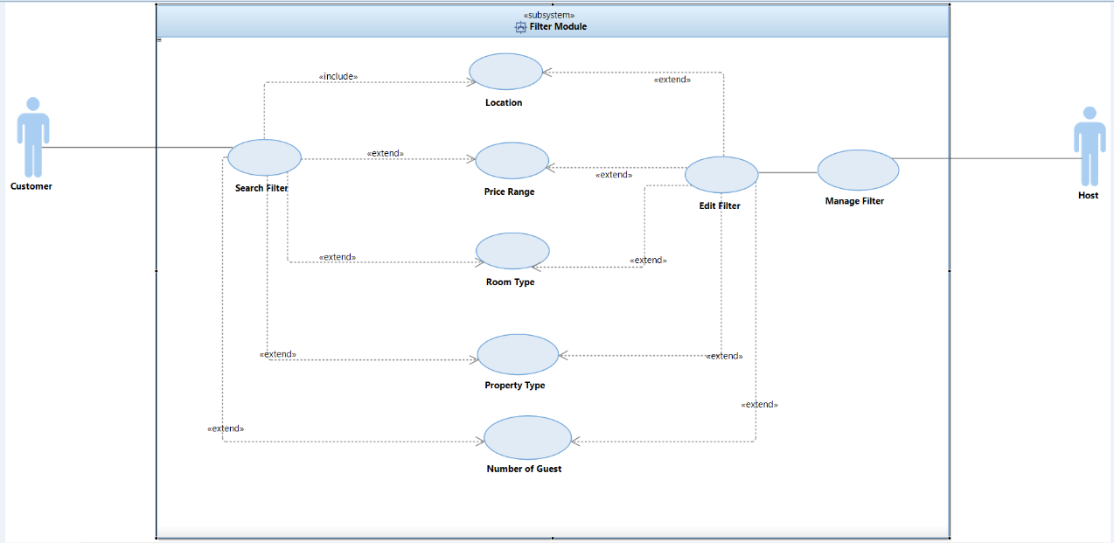

**Figure 3.8:** Decompose Use Case Search Homestay Module

**Table 3.4** Search Homestay Use Case Description

|  |  |
| --- | --- |
| **Use Case ID** | HMS-UCD-04 |
| **Brief Description** | Customer searches for available homestays based on search filters. Host can add filters to their homestay. |
| **Actor** | Host and Customer |
| **Pre-Conditions** | Customer or Host needs to be logged in. |
| **Basic Flow** | Customer   1. The customer input the desired filter for the homestay. 2. Available homestays will be displayed based on filters.   Host   1. Host adds filters for their homestay. |
| **Alternative Flow** | N/A |
| **Exception Flow** | 1. No available homestay based on customer’s search filter.   1a. Customer changes the filters. |
| **Post-Conditions** | The system will show the result of the customer search filter.  The system will show the form to edit the filter for the host. |
| **Rules** | N/A |
| **Constraints** | Customer cannot search any other filters that are not stated in the search filter.  Host cannot fill in other filter that are not stated in the search filter. |
| **Activity Diagram** | A-4 : Activity diagram |

### 3.1.5 View Promotional Offer Use Case

Figure 3.9, 3.10 and table 3.5 show the use case, decomposed use case (sea level) and use case description of checking promotional offer from the view promotional offer module.

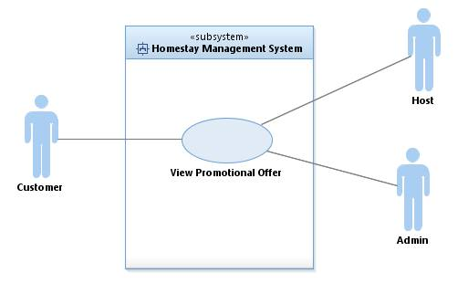

**Figure 3.9:** Use Case for View Promotional Offer Module.

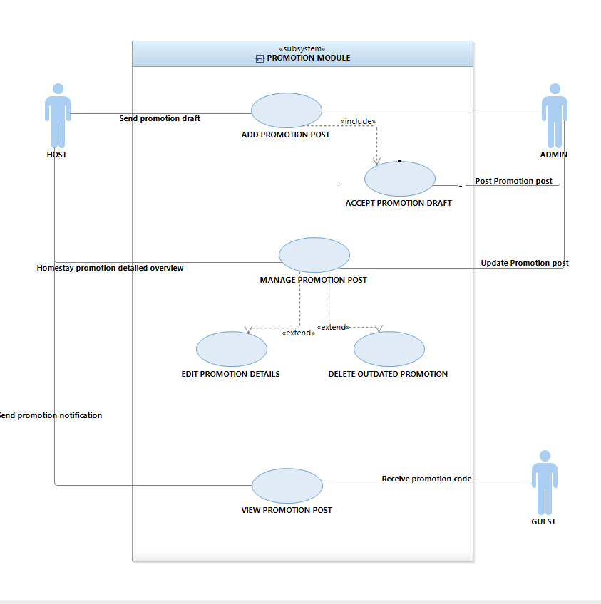

**Figure 3.10:** Decompose Use Case View Promotional Offer Module

**Table 3.5** View Promotional Offer Use Case Description

|  |  |
| --- | --- |
| **Use Case ID** | HMS-UCD-05 |
| **Brief Description** | Host and Admin manages promotional offers. Customer can view all the promotional offers. |
| **Actor** | Hosts, Admin and customers |
| **Pre-Conditions** | Host,Admin and customers need to login to the system |
| **Basic Flow** | Host   1. Hosts are given three option whether add new promotion, manage the promotion post and view the promotion post.   Admin   1. Admin can view the promotion drafts, accept promotion request and add promotion post. 2. Admin can manage promotion posts.   Customer   1. Customer can view or check the promotion offers. 2. Customer can choose the promotion and receive promotion code. |
| **Alternative Flow** | N/A |
| **Exception Flow** | 1. Network error. |
| **Post-Conditions** | Hosts, admin and customer successfully manage the promotion offer. |
| **Rules** | N/A |
| **Constraints** | 1. Customers can only choose one promotion offers. 2. Hosts can only post the promotion once the admin accept their requests. |
| **Activity Diagram** | Refer Appendix  A-5 : Activity diagram |

### 3.1.6 Manage Tourism Services Use Case

Figure 3.11, 3.12 and table 3.6 show the use case, decomposed use case (sea level) and use case description of tourism services management offer from the manage tourism services module.

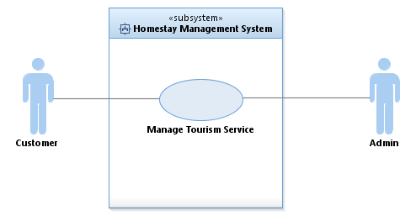

**Figure 3.11:** Use Case Manage Tourism ServicesModule

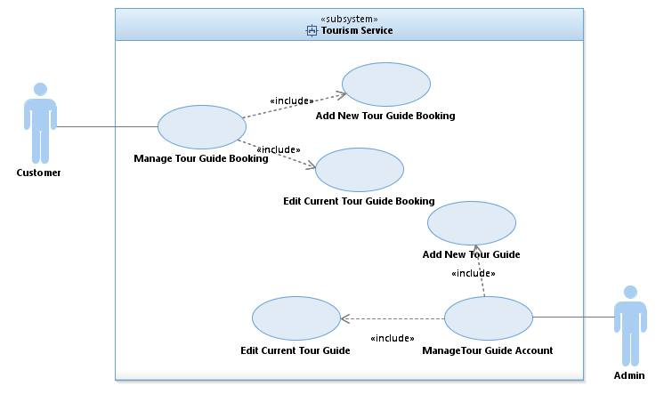

**Figure 3.12:** Decompose Use Case Manage Tourism ServicesModule

**Table 3.6** Manage Tourism ServicesUse Case Description

|  |  |
| --- | --- |
| **Use Case ID** | HMS-UCD-06 |
| **Brief Description** | This use case use allow host to manage tourism service by make them able to provide service to customer better. |
| **Actor** | Admin and customer |
| **Pre-Conditions** | User must login into the system. |
| **Basic Flow** | Customer   1. After customer login into the system, customer need to click tour guide service button 2. Customer get two option either add new tour guide service or edit current tour guide booking. 3. Customer need to click add new tour guide option in order able to view current tour guide booking list. 4. Customer should fill the information needed in the tour guide form provided. 5. After fill the information, tour guide list displayed after click at the button provided. 6. Customer need to select tour guide for complete the tour guide booking process. 7. After successfully finish the booking, customer edit current tour guide booking. 8. Customer able to update the tour guide details or cancel the booking. 9. Customer must logout the system by using logout button provided.   Admin   1. After admin login into the system, admin able to add and edit current tour guide account. 2. Admin insert tour guide information into the form given before edit current tour guide. 3. Admin able to edit the current tour guide either admin want to update or delete the account. 4. Admin must logout from the system using logout button provided. |
| **Alternative Flow** | 1. Customer unable to submit guide tour information form. 2. Reload the page 3. Fill the form again 4. Customer able to submit guide tour information again |
| **Exception Flow** | 1. Customer unable to submit guide tour information form. 2. Back to main interface 3. Go to service tour guide interface 4. Enter add tour guide   Fill the form again and successfully submit the guide tour information |
| **Post-Conditions** | Customer successfully submits the guide tour information form. |
| **Rules** | N/A |
| **Constraints** | Admin cannot add tour guide details for multiple people. |
| **Activity Diagram** | Refer Appendix  A-6 : Activity diagram |

## 3.2 User Interfaces Requirements

3.2.1 Graphical User Interface

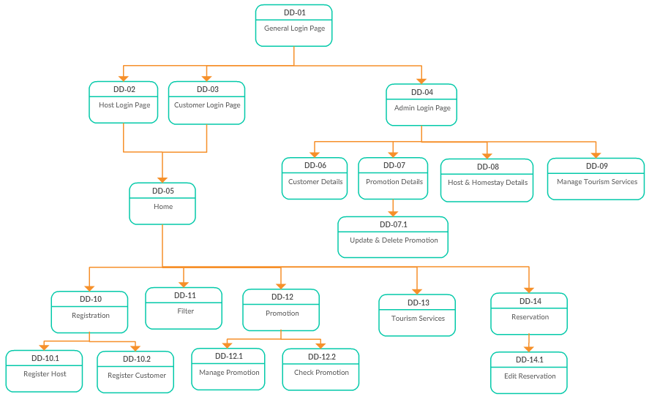

**Figure 3.13: Dialog Diagram for HMS**

**Table 3.7 Description of user interface components**

|  |  |  |
| --- | --- | --- |
| **User Interface Name or Number** | **Description** | **User Interface Layout** |
| General Login Page | User can choose the user type either admin, host or customer | Refer Appendix B-1 |
| Host Login | Host user shall key-in their user ID and password | Refer Appendix B-2 |
| Customer Login | Customer user shall key-in their user ID and password | Refer Appendix B-3 |
| Admin Login | Admin user shall key-in their user ID and password | Refer Appendix B-4 |
| Home | Home page which shows menu and brief description of the system | Refer Appendix B-5 |
| Customer Details | Admin will able to view customer details | Refer Appendix B-6 |
| Accept Promotion | Admin will decide whether accept or decline promotion request from hosts | Refer Appendix B-7 |
| Update and Delete Promotion | Admin can update and delete all the outdated promotion | Refer Appendix B-8 |
| Host & Homestay Details | Admin can view host details including their homestays’ details | Refer Appendix B-9 |
| Manage Tourism Services | Admin can view or update tour guide information | Refer Appendix B-10 |
| Registration | User can choose the user type either admin, host or customer | Refer Appendix B-11 |
| Host Registration | Homestay owner will register as host and add their homestay’s details | Refer Appendix B-12 |
| Customer Registration | Customer has to fill up registration form before making reservation | Refer Appendix B-13 |
| Homestay Filter | Platform for customers to filter their search result easily | Refer Appendix B-14 |
| Check Promotion | Customer can check and choose promotion offered | Refer Appendix B-15 |
| Manage Promotion | Host can request to add promotion and edit promotion | Refer Appendix B-16 |
| Tourism Services | Customer can choose and book tour guide packages | Refer Appendix B-17 |
| Reservation | Customer can make a reservation for homestay | Refer Appendix B-18 |
| Edit Reservation | Customer can edit or delete their existing reservation | Refer Appendix B-19 |

3.2.2 Hardware Interface

Not Applicable.

3.2.3 Software Interface

Table 3.8 shows the software interface that is being used in the system.

**Table 3.8 Software Interface**

|  |  |
| --- | --- |
| **Product** | **Function** |
| Xampp | To run the system |
| Hosting | To run the web-based system |
| MySQL | Database platform |

* 1. **Requirements Traceability**

Figure 3.14 shows the requirement traceability in this Homestay Management System.

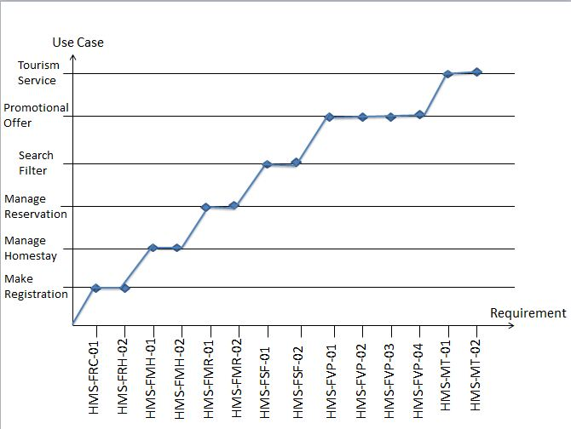

**Figure 3.14: Traceability matrix for Use Case and Requirement**

|  |  |
| --- | --- |
| **System Requirement** | **Use Case Name** |
| HMS-FRC-01 | Use Case Registration Customer |
| HMS-FRH-02 | Use Case Registration Host |
| HMS-FMH-01 | Use Case Manage Homestay |
| HMS-FMH-02 | Use Case Manage Homestay |
| HMS-FMR-01 | Use Case Manage Reservation |
| HMS-FMR-02 | Use Case Manage Reservation |
| HMS-FSF-01 | Use Case Search Filter |
| HMS-FSF-02 | Use Case Search Filter |
| HMS-FVP-01 | Use Case View Promotional Offer |
| HMS-FVP-02 | Use Case View Promotional Offer |
| HMS-FVP-03 | Use Case View Promotional Offer |
| HMS-FVP-04 | Use Case View Promotional Offer |
| HMS-FMT-01 | Use Case Manage Tourism Service |
| HMS-FMT-02 | Use Case Manage Tourism Service |

**Table 3.9: Traceability matrix for Requirement and Use Case**

# 4. ACRONYMS AND ABBREVIATION

Table 4.1 shows the acronyms and abbreviation when preparing this software requirement specifications.

**Table 4.1** Acronyms and Abbreviations

|  |  |
| --- | --- |
| **Term** | **Definition** |
| TITSB | The Insight Techaware Sdn Bhd |
| SRS | Software Requirement Specification |
| HMS | Homestay Management System |
| DD | Dialogue Diagram |
| PHP | PHP: Hypertext Preprocessor |
| FRC | Functional Requirement for Customer |
| FRH | Functional Requirement for Host |
| FMH | Functional Requirement for Manage Homestay |
| FSF | Functional Requirement for Search Filter |
| FMR | Functional Requirement for Manage Reservation |
| FVP | Functional Requirement for View Promotional Offer |
| FMT | Functional Requirement for Manage Tourism Service |
| SQL | Structure Query Language |
| UCD | Use Case Diagram |

**APPENDIX A**

**Activity diagram**

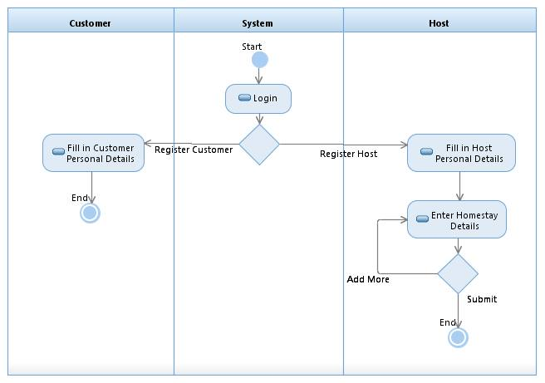

A-1 Registration Activity Diagram

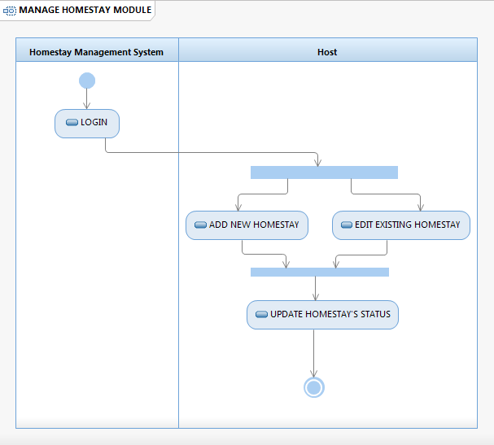

A-2 Manage Homestay Activity Diagram

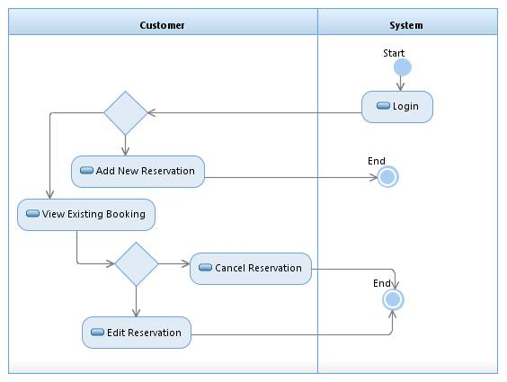

A-3 Reservation Activity Diagram

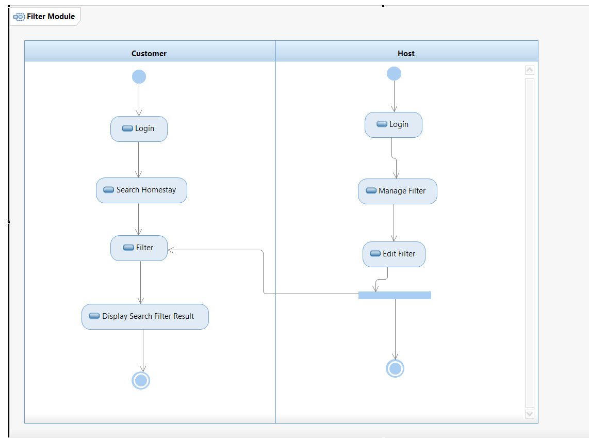

A-4 Filter Activity Diagram

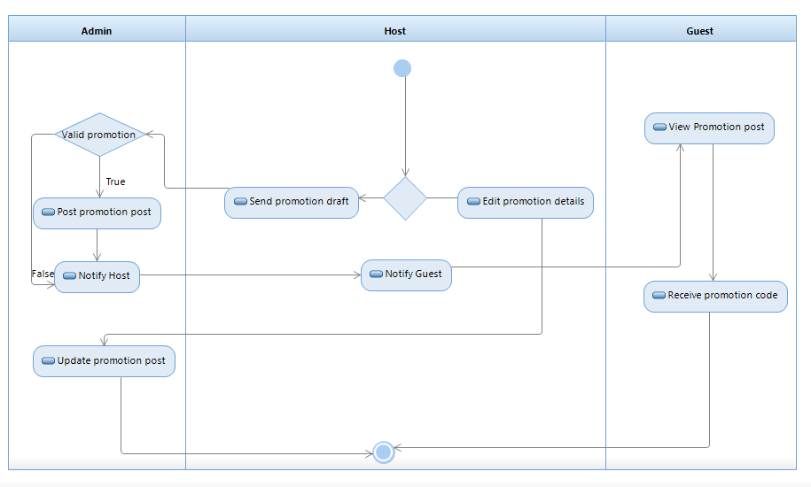

A-5 Promotion Activity Diagram

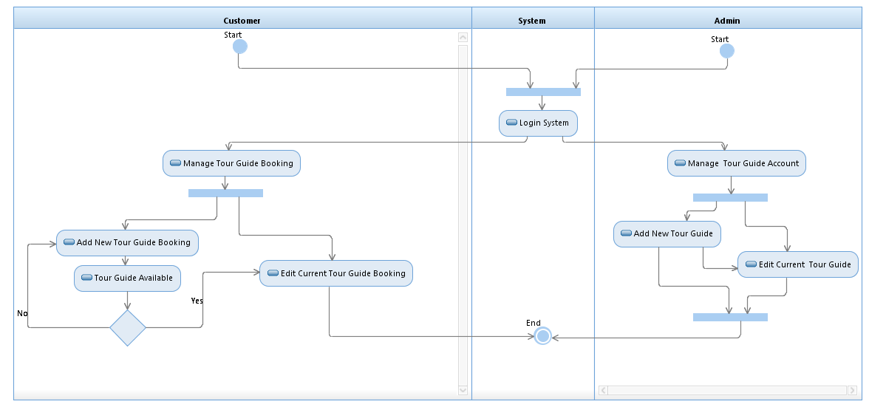

A-6 Tourism Services Activity Diagram

**APPENDIX B**

**User interface**

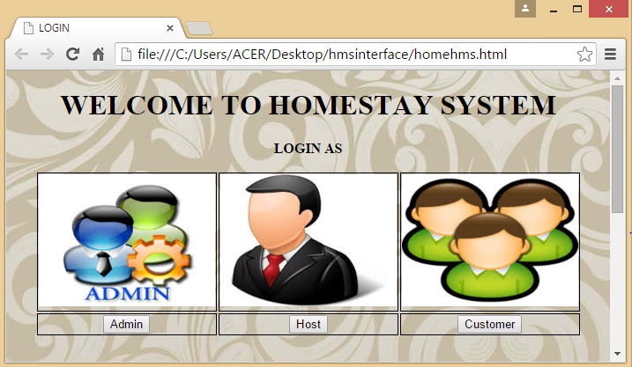

B-1 General Login Page

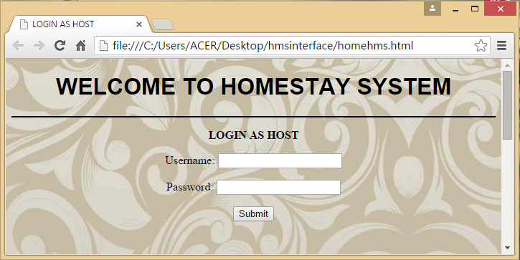

B-2 Host Login Page

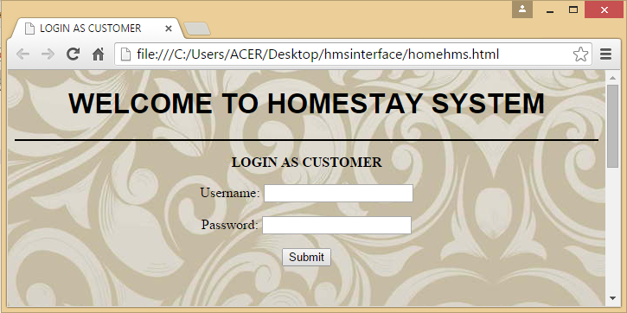

B-3 Customer Login Page

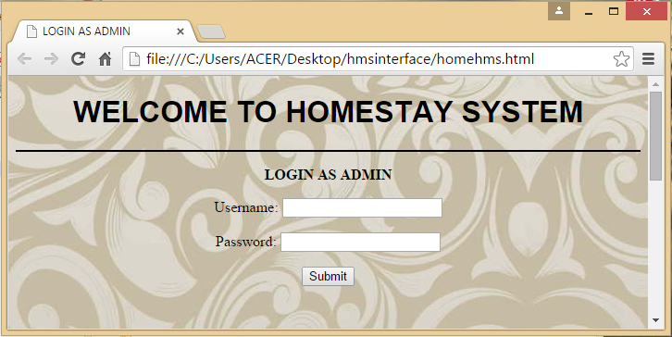

B-4 Admin Login Page

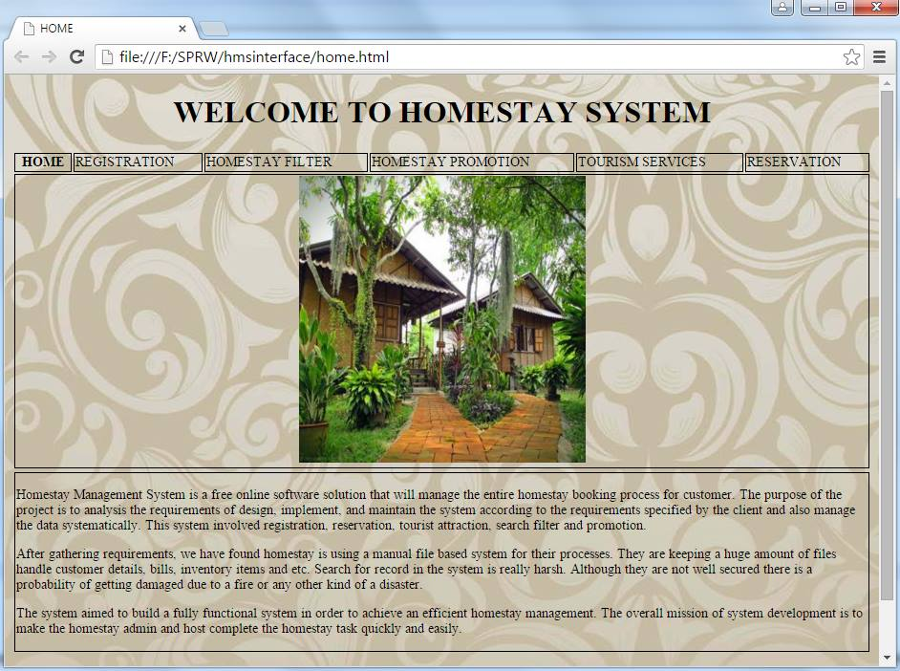

B-5 Home Page

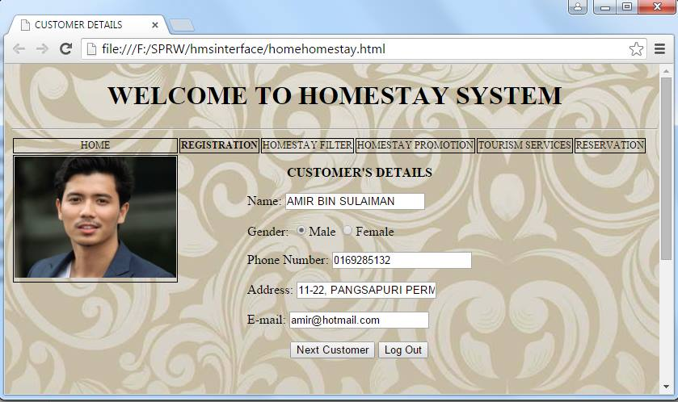

B-6 Customer Details Page

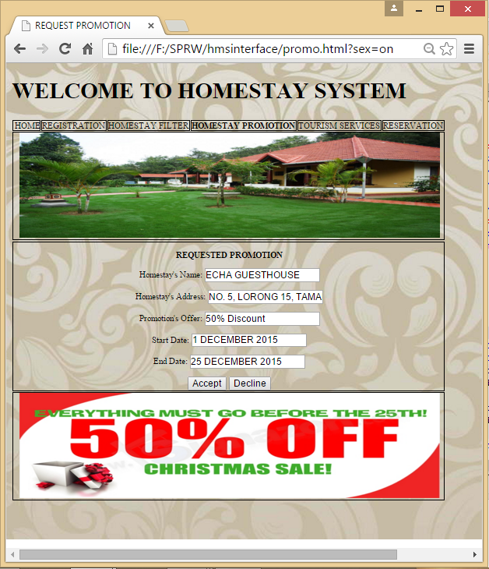

B-7 Accept promotion page

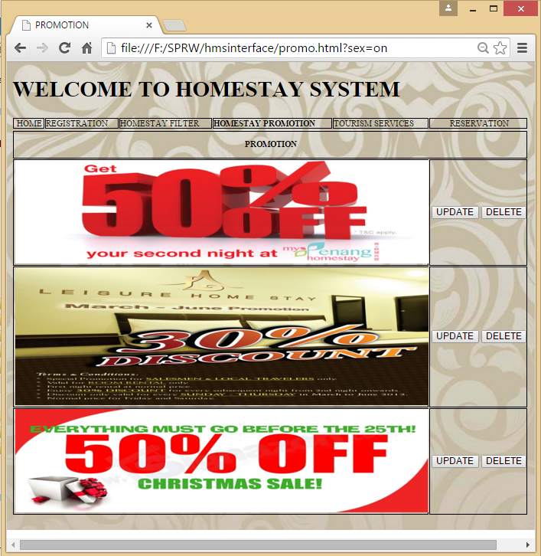

B-8 Update & Delete Promotion Page

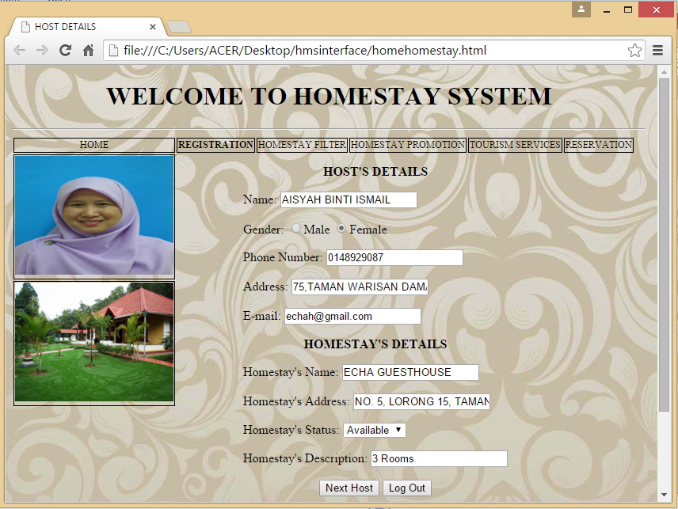

B-9 Host & Homestay Details Page

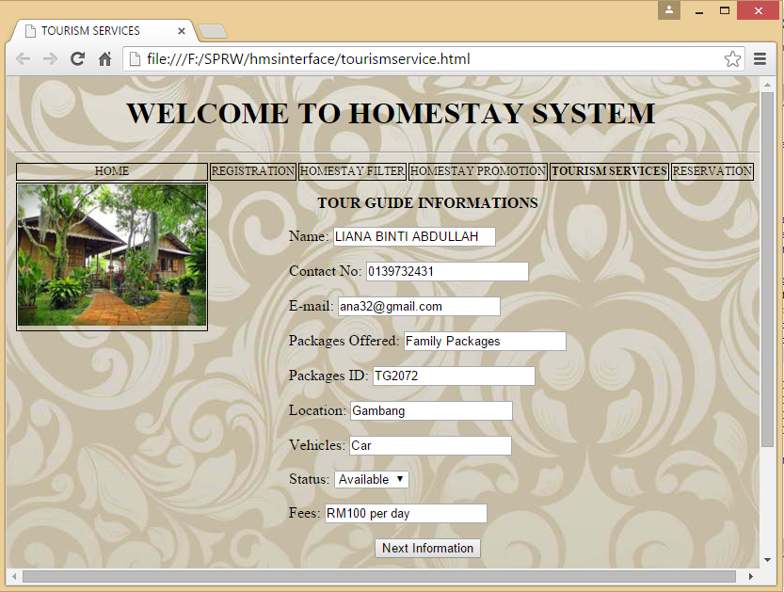

B-10 Manage Tourism Services Page

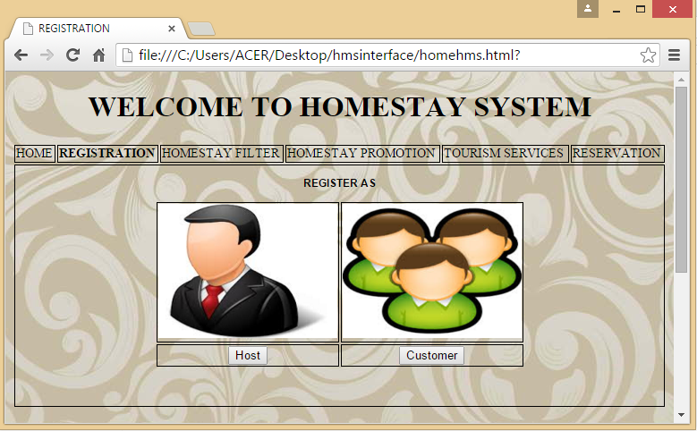

B-11 Registration Page

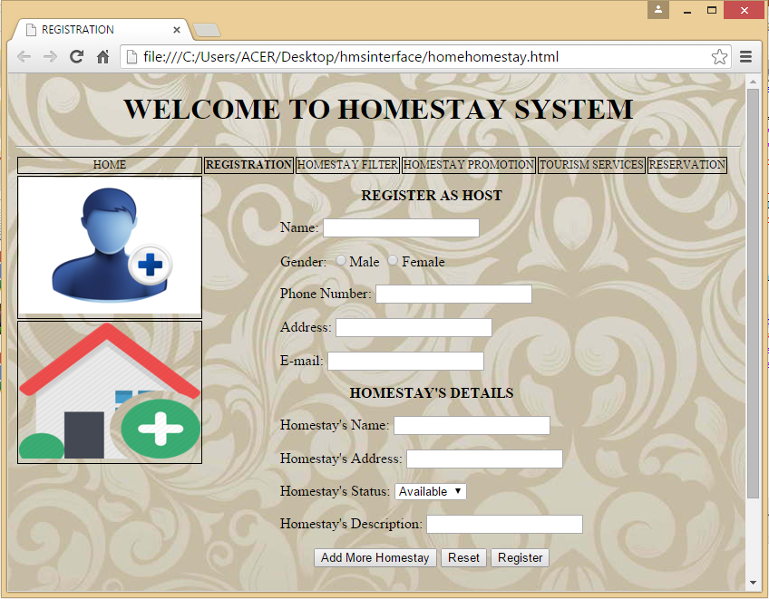

B-12 Host Registration Page

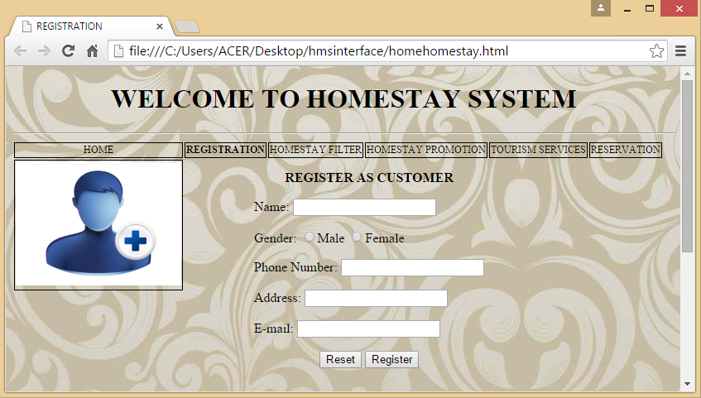

B-13 Customer Registration Page

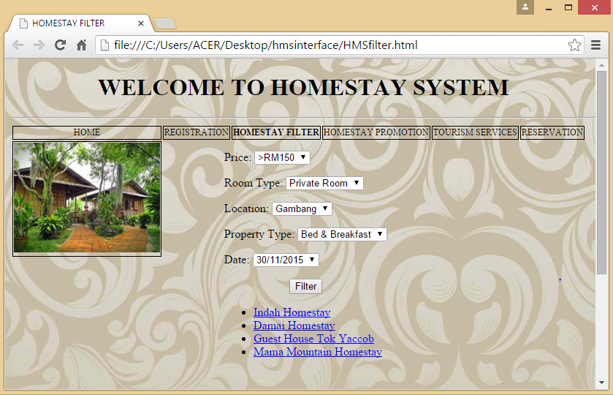

B-14 Homestay Filter Page

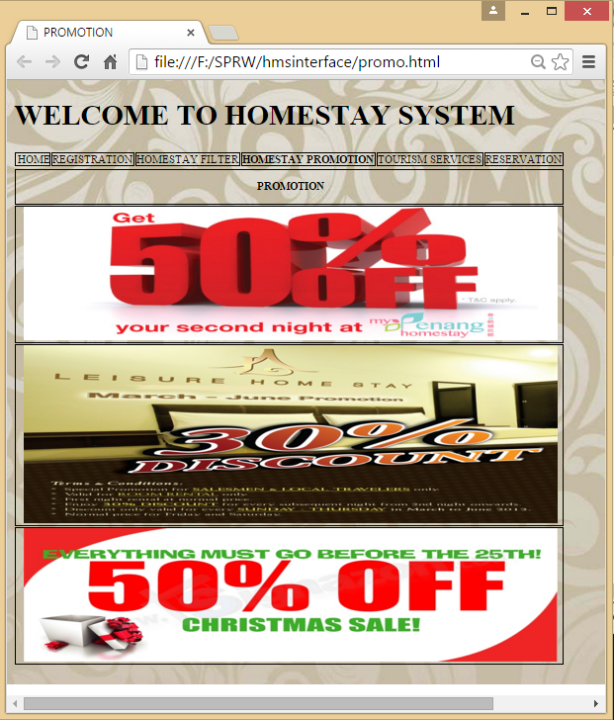

B-15 Check Promotion Page

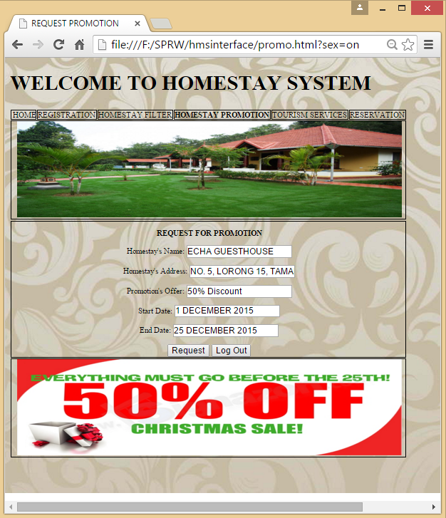

B-16 Manage Promotion Page

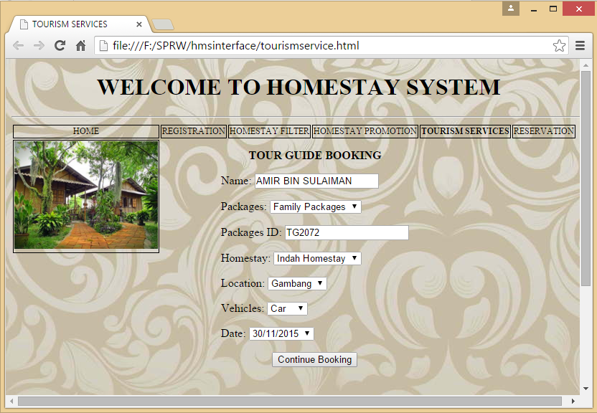

B-17 Tourism Services Page

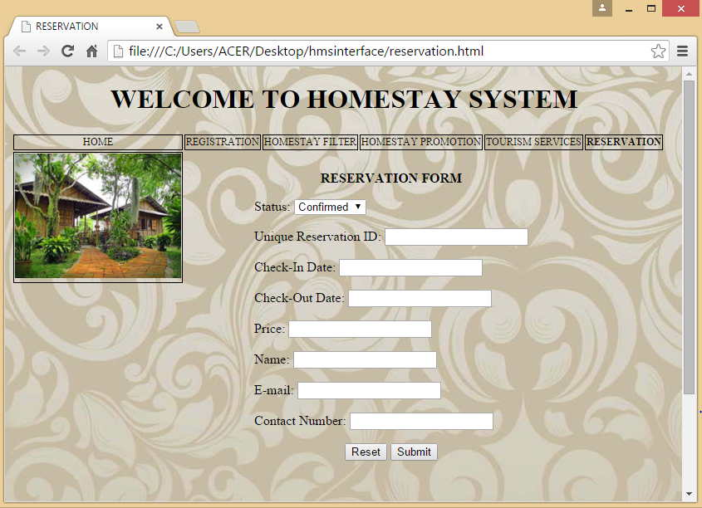

B-18 Reservation Page

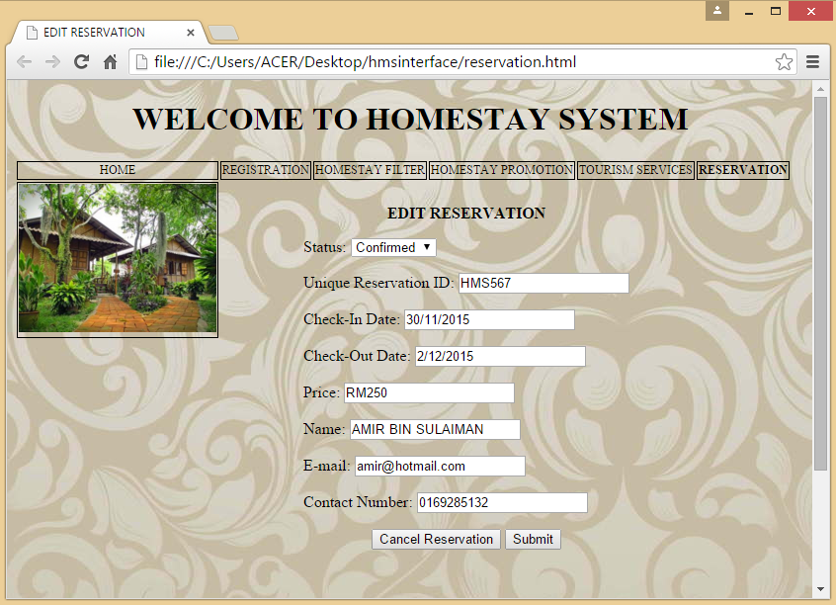

B-19 Edit Reservation Page

**APPENDIX C**

**Photo**

